Ideation Phase
Define the Problem Statements
Date | 26 November 2025
Team ID
Project Name | Bookstore
Maximum Marks | 2 Marks
Customer Problem Statement Template:
To define the core problems users face while browsing, buying, and reviewing books online, and use those insights to guide the development of the Online Bookstore.
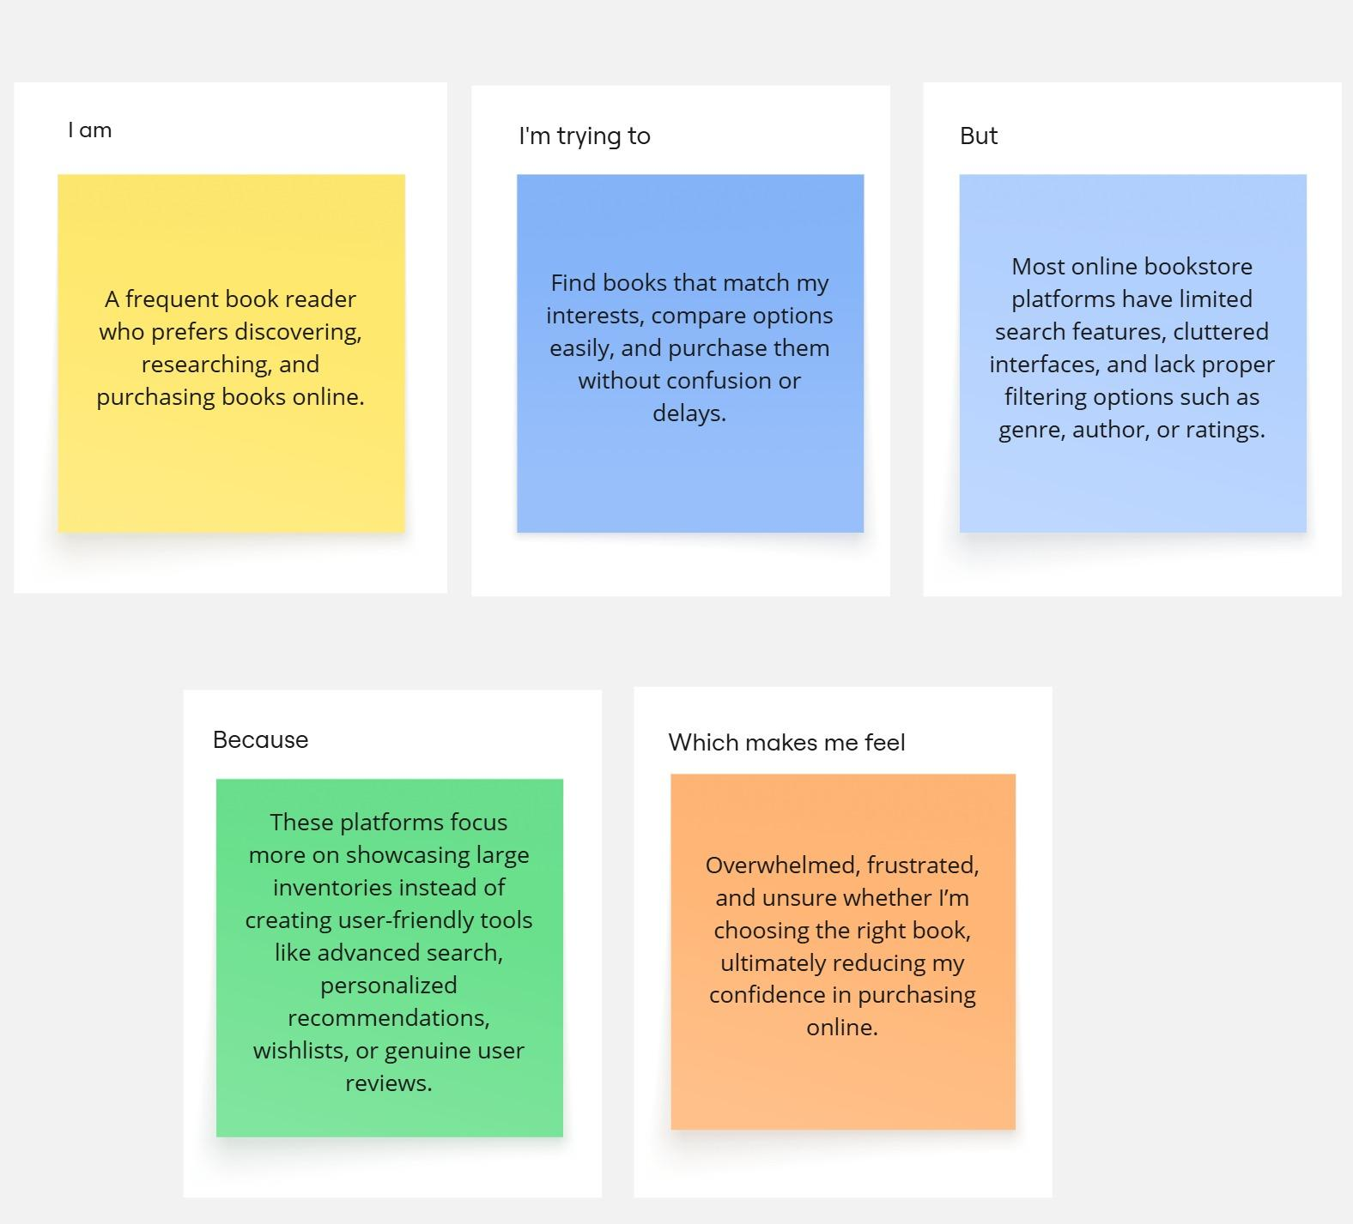

Problem Statement (PS) | I am (Customer) | I’m trying to | But | Because | Which makes me feel
PS-1 | An avid reader who regularly buys books online. | Find books that match my reading interests efficiently. | Existing platforms have limited or inconsistent search and filter options. | Search results are often cluttered, poorly categorized, or lack filters like genre, author, or ratings. | Frustrated and overwhelmed when trying to discover books I might actually enjoy.
PS-2 | A user who likes to track books I want to buy or read. | Maintain a wishlist and organize my future reading. | Most bookstore platforms don’t provide intuitive wishlist features or personalized recommendations. | The system doesn't understand my reading preferences or lacks dedicated wishlist and cart functionalities. | Unorganized and unsatisfied with the online purchase experience.

